- Google Drive > Travel Order Automate

- Open TEV Automation - Template -> File > Share -> Share with Others -> Copy Link
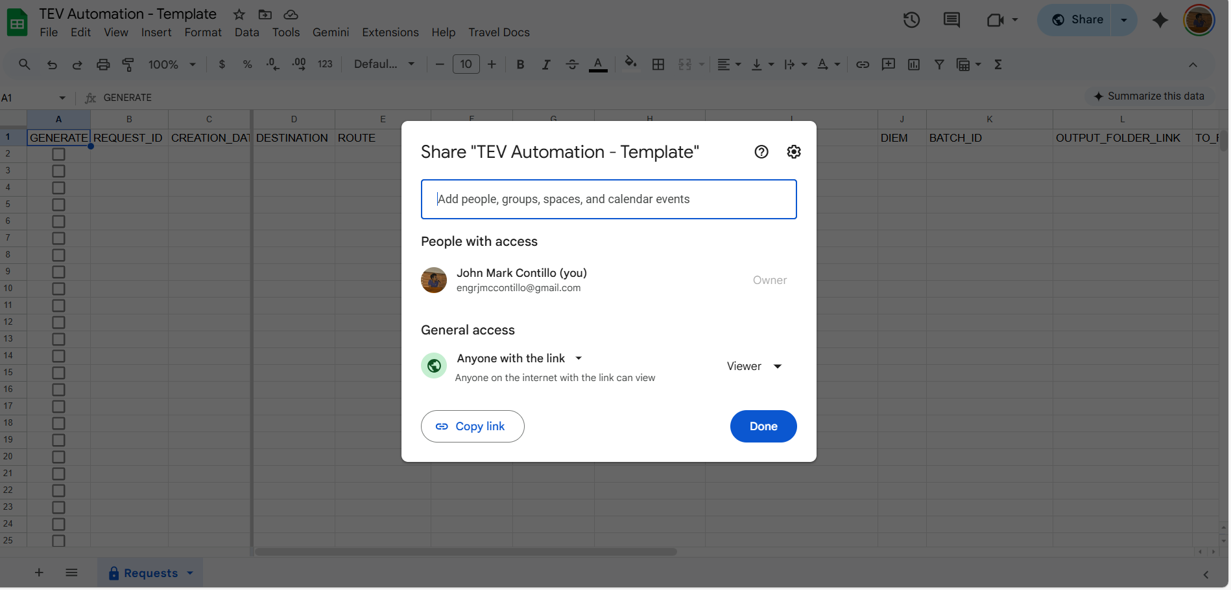

- On another account, open the link (e.g. https://docs.google.com/spreadsheets/d/1lr3kt3lF7wjLOTLKT30Cc75kzdMFyQbjlAYD4MVRWBY/edit?usp=sharing) > Make a Copy > Change Name
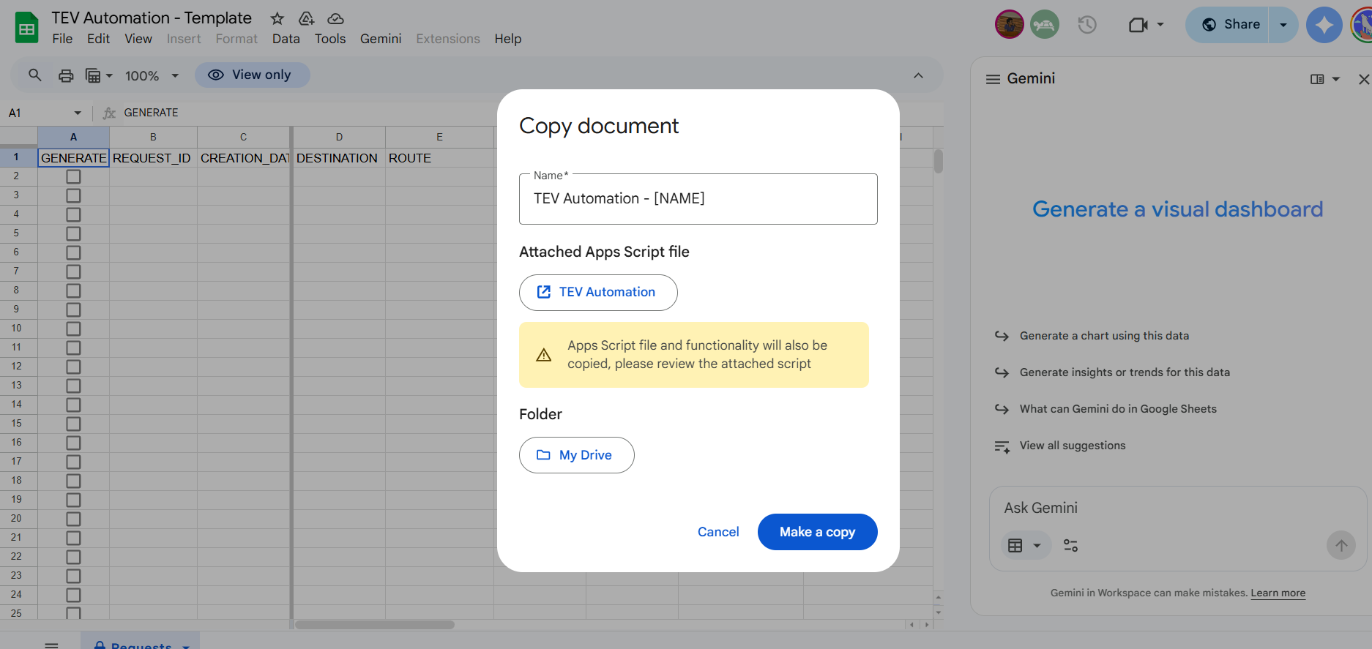
- Authorize > Advance > Go to TEV Automation (unsafe) > Select All > Continue
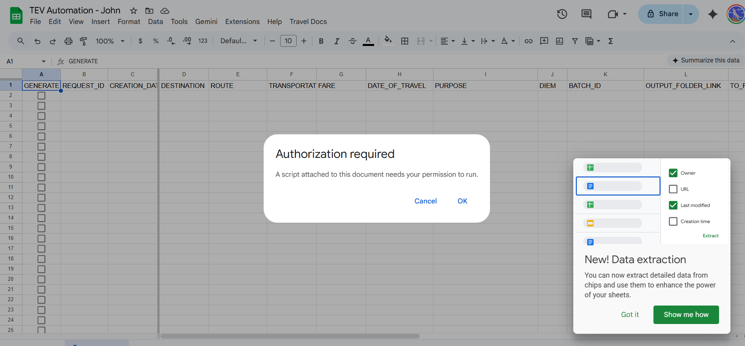
- Download zip file from 1 > extract > create folder in google drive (e.g Travel Order Files) >Upload the folders
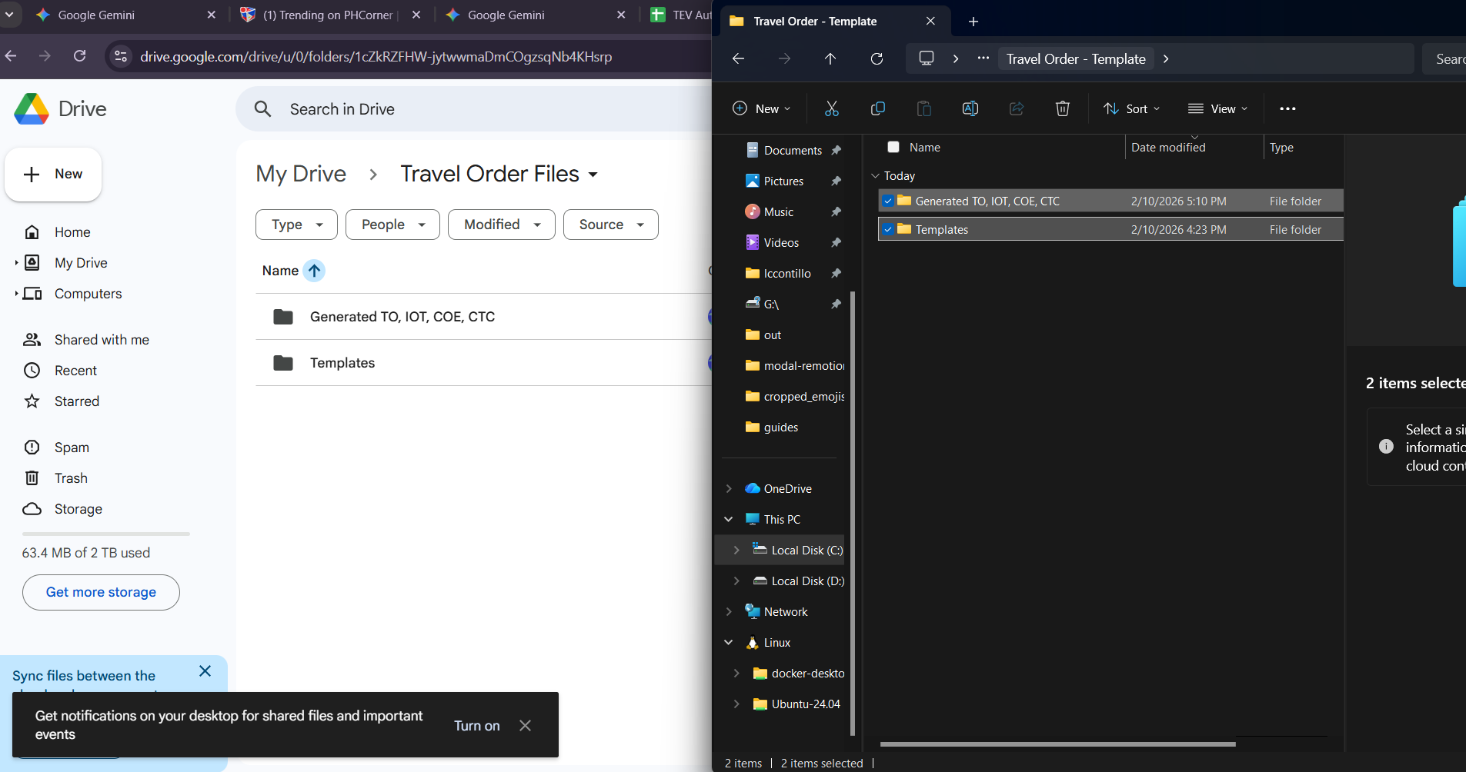
- TEV Automation - [NAME] > Travel Docs > Setup: Configure Folders
Step 1: Open Templates Folder in google drive > Copy Folder ID (e.g. https://drive.google.com/drive/folders/1H7h21OjzqjgvrHjfaYJLE_Okh_7qxrrk)
Step 2: Open Generate TO .. folder > Copy Folder ID (e.g. https://drive.google.com/drive/folders/1E2SSAFbj2NvUF-FVLD0DNSlCYxO_mSwM)
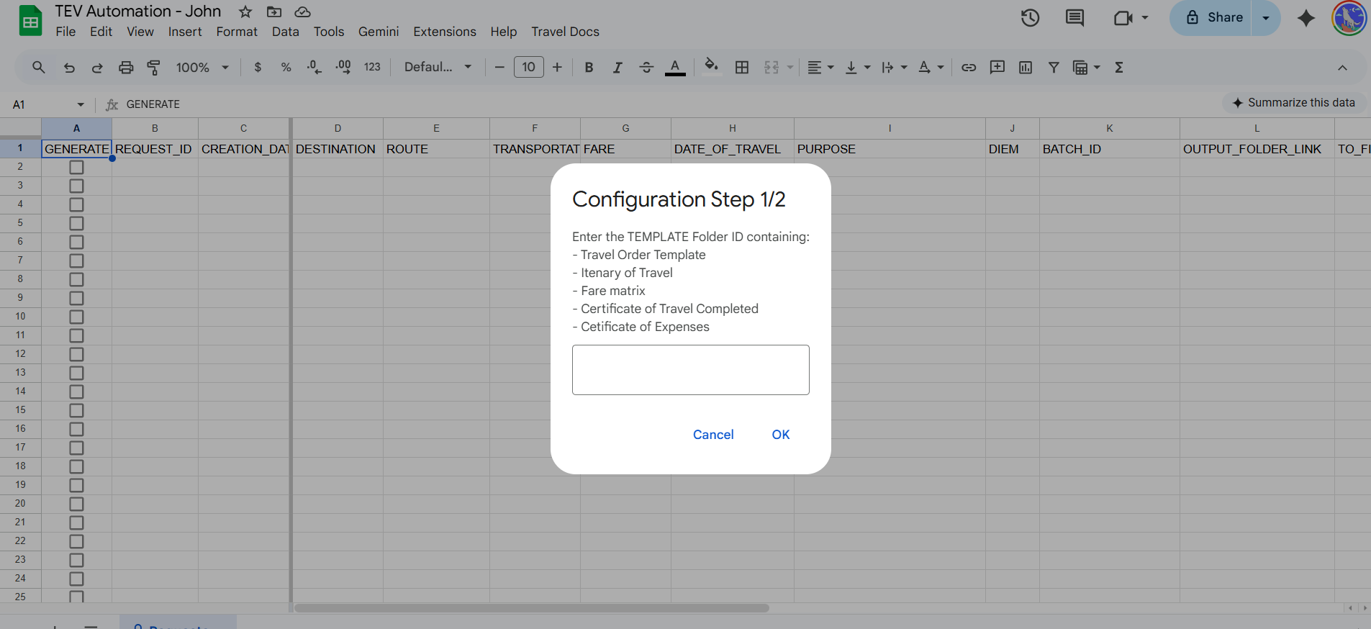
Step:3 Wait until configuration script is finished
